**Assignment 1**

**Task 1:- Install Jupyter notebook and run the first program and share the screenshot of the output.**

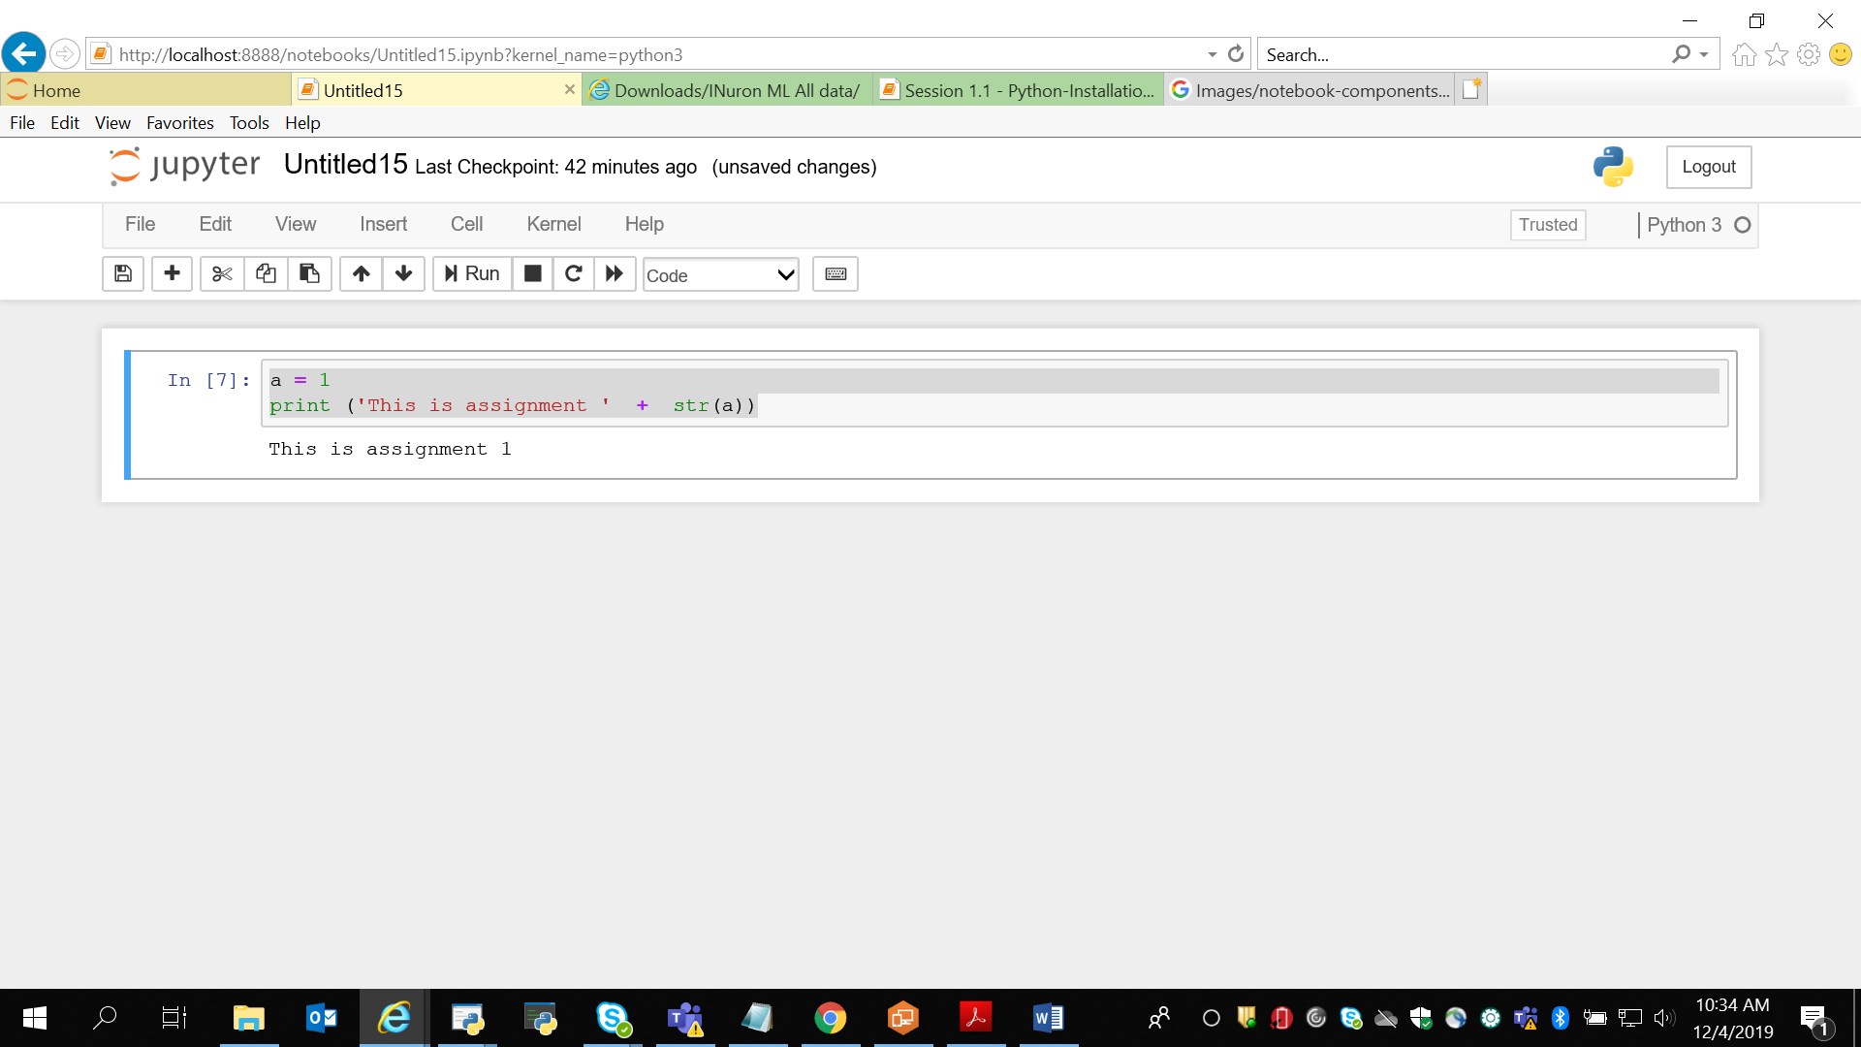

**2. Write a program which will find all such numbers which are divisible by 7 but are not a multiple of 5, between 2000 and 3200 (both included). The numbers obtained should be printed in a comma-separated sequence on a single line**.

**my_list2 = list (range(2000, 2050))**

**print(my_list2)**

**i=0**

**for i in my_list2:**

**if(i % 7==0 and i % 5 != 0):**

**# if (i % 5 != 0):**

**print(i)**

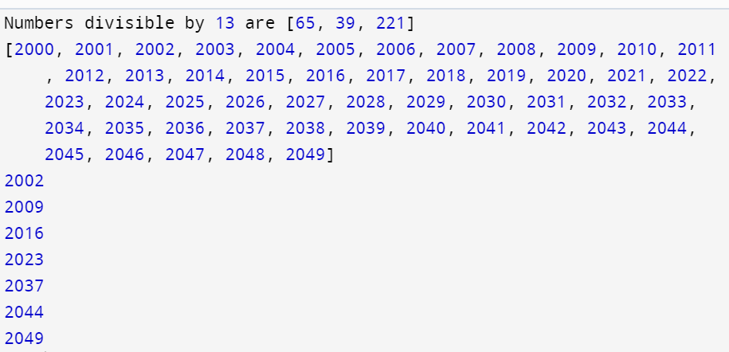

**3.**

**Write a Python program to accept the user's first and last name and then getting them printed in**

**the reverse order with a space between first name and last name**.

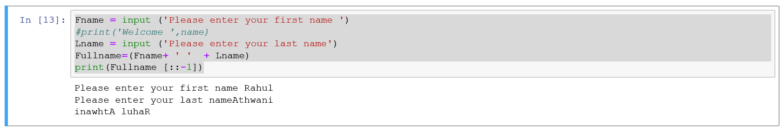

4. **Write a Python program to find the volume of a sphere with diameter 12 cm.**

**Formula: V=4/3 * π * r 3**

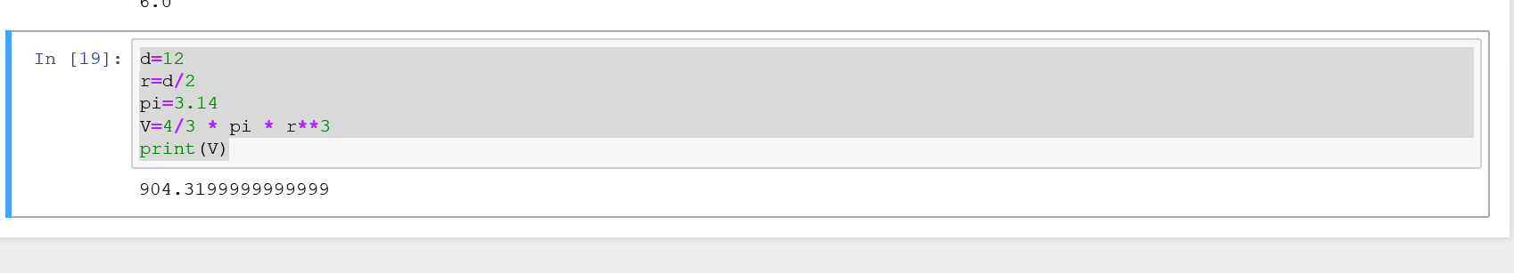

**Task 2:**

**1.**

**Write a program which accepts a sequence of comma-separated numbers from console and**

**generate a list.**

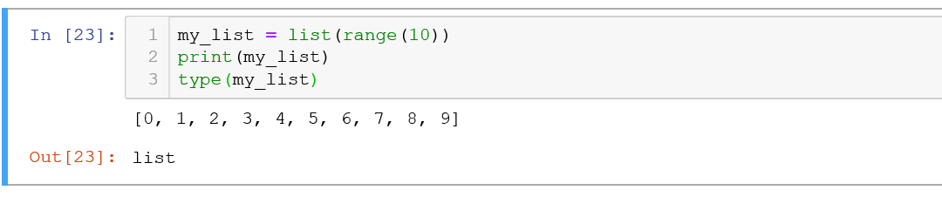

2.

Create the below pattern using nested for loop in Python.

*

* *

* * *

* * * *

* * * * *

* * * *

* * *

* *

*

3.

Write a Python program to reverse a word after accepting the input from the user.

**Sample Output:**

Input word: AcadGild

Output: dilGdacA

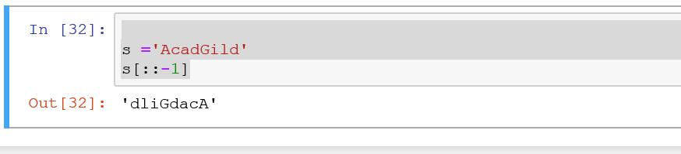

4.

Write a Python Program to print the given string in the format specified in the **sample output.**

WE, THE PEOPLE OF INDIA, having solemnly resolved to constitute India into a

SOVEREIGN, SOCIALIST, SECULAR, DEMOCRATIC REPUBLIC and to secure to all

its citizens